**MQTT Base Firmware Document**

**Table of Contents**………………………………………………………………**3**

1. **Introduction**…………………………………………………………….**4**
2. **Procedure……………………………………………………………….**

**Introduction:**

This document provides information about MQTT base firmware. This MQTT base firmware needs to be dumped before the user-made firmware is used.

**Procedure:**

1. Find the MQTT base firmware file and dump the firmware by Q-flash software. It will take some time to pass the firmware successfully.
2. While using the Q-flash to dump the base firmware of the MQTT, make sure that J2 must be short. Otherwise, the external watchdog will reset the module.

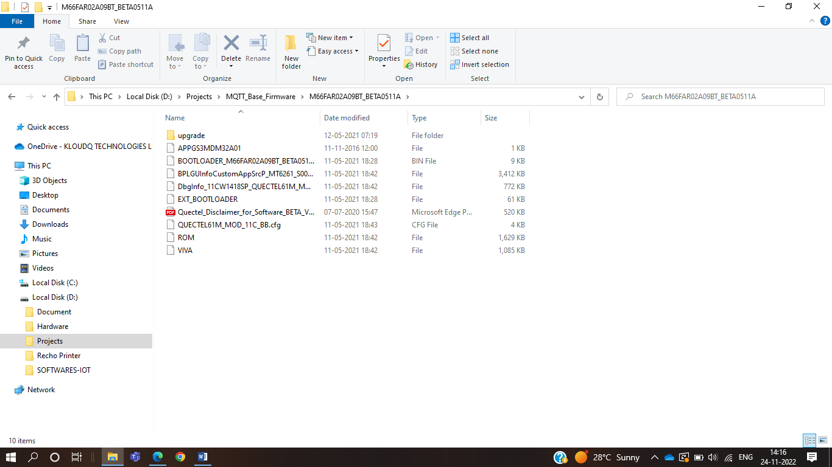

1. Select .cfg file to dump the firmware.
2. Use Q-flash to dump the firmware.

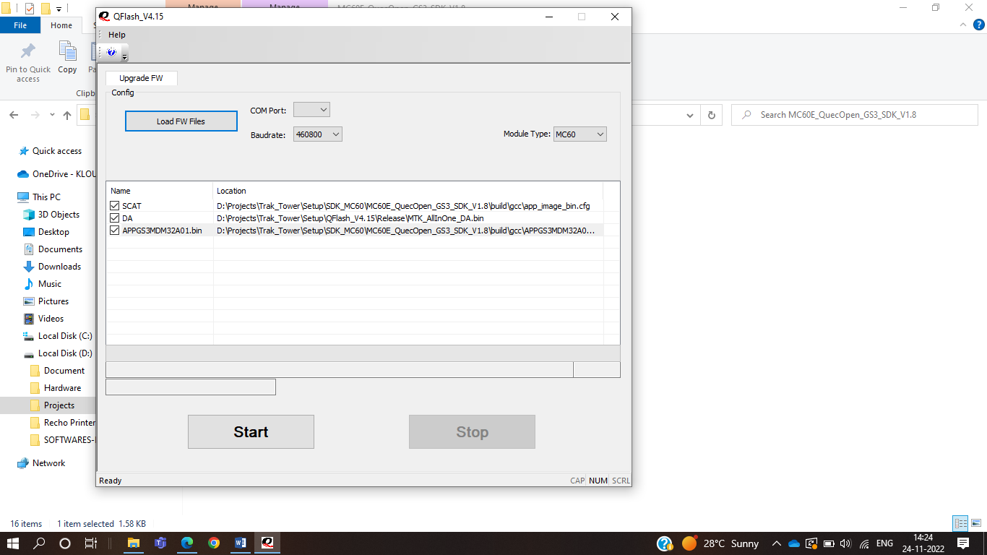

1. Select .cfg file from Q-flash software.

